***Open Education ***

08 October 28, 2013

*The task of the modern educator is not to cut down jungles, but to irrigate deserts -* [*C.S. Lewis*](http://www.goodreads.com/author/show/1069006.C_S_Lewis)

**Workshop**

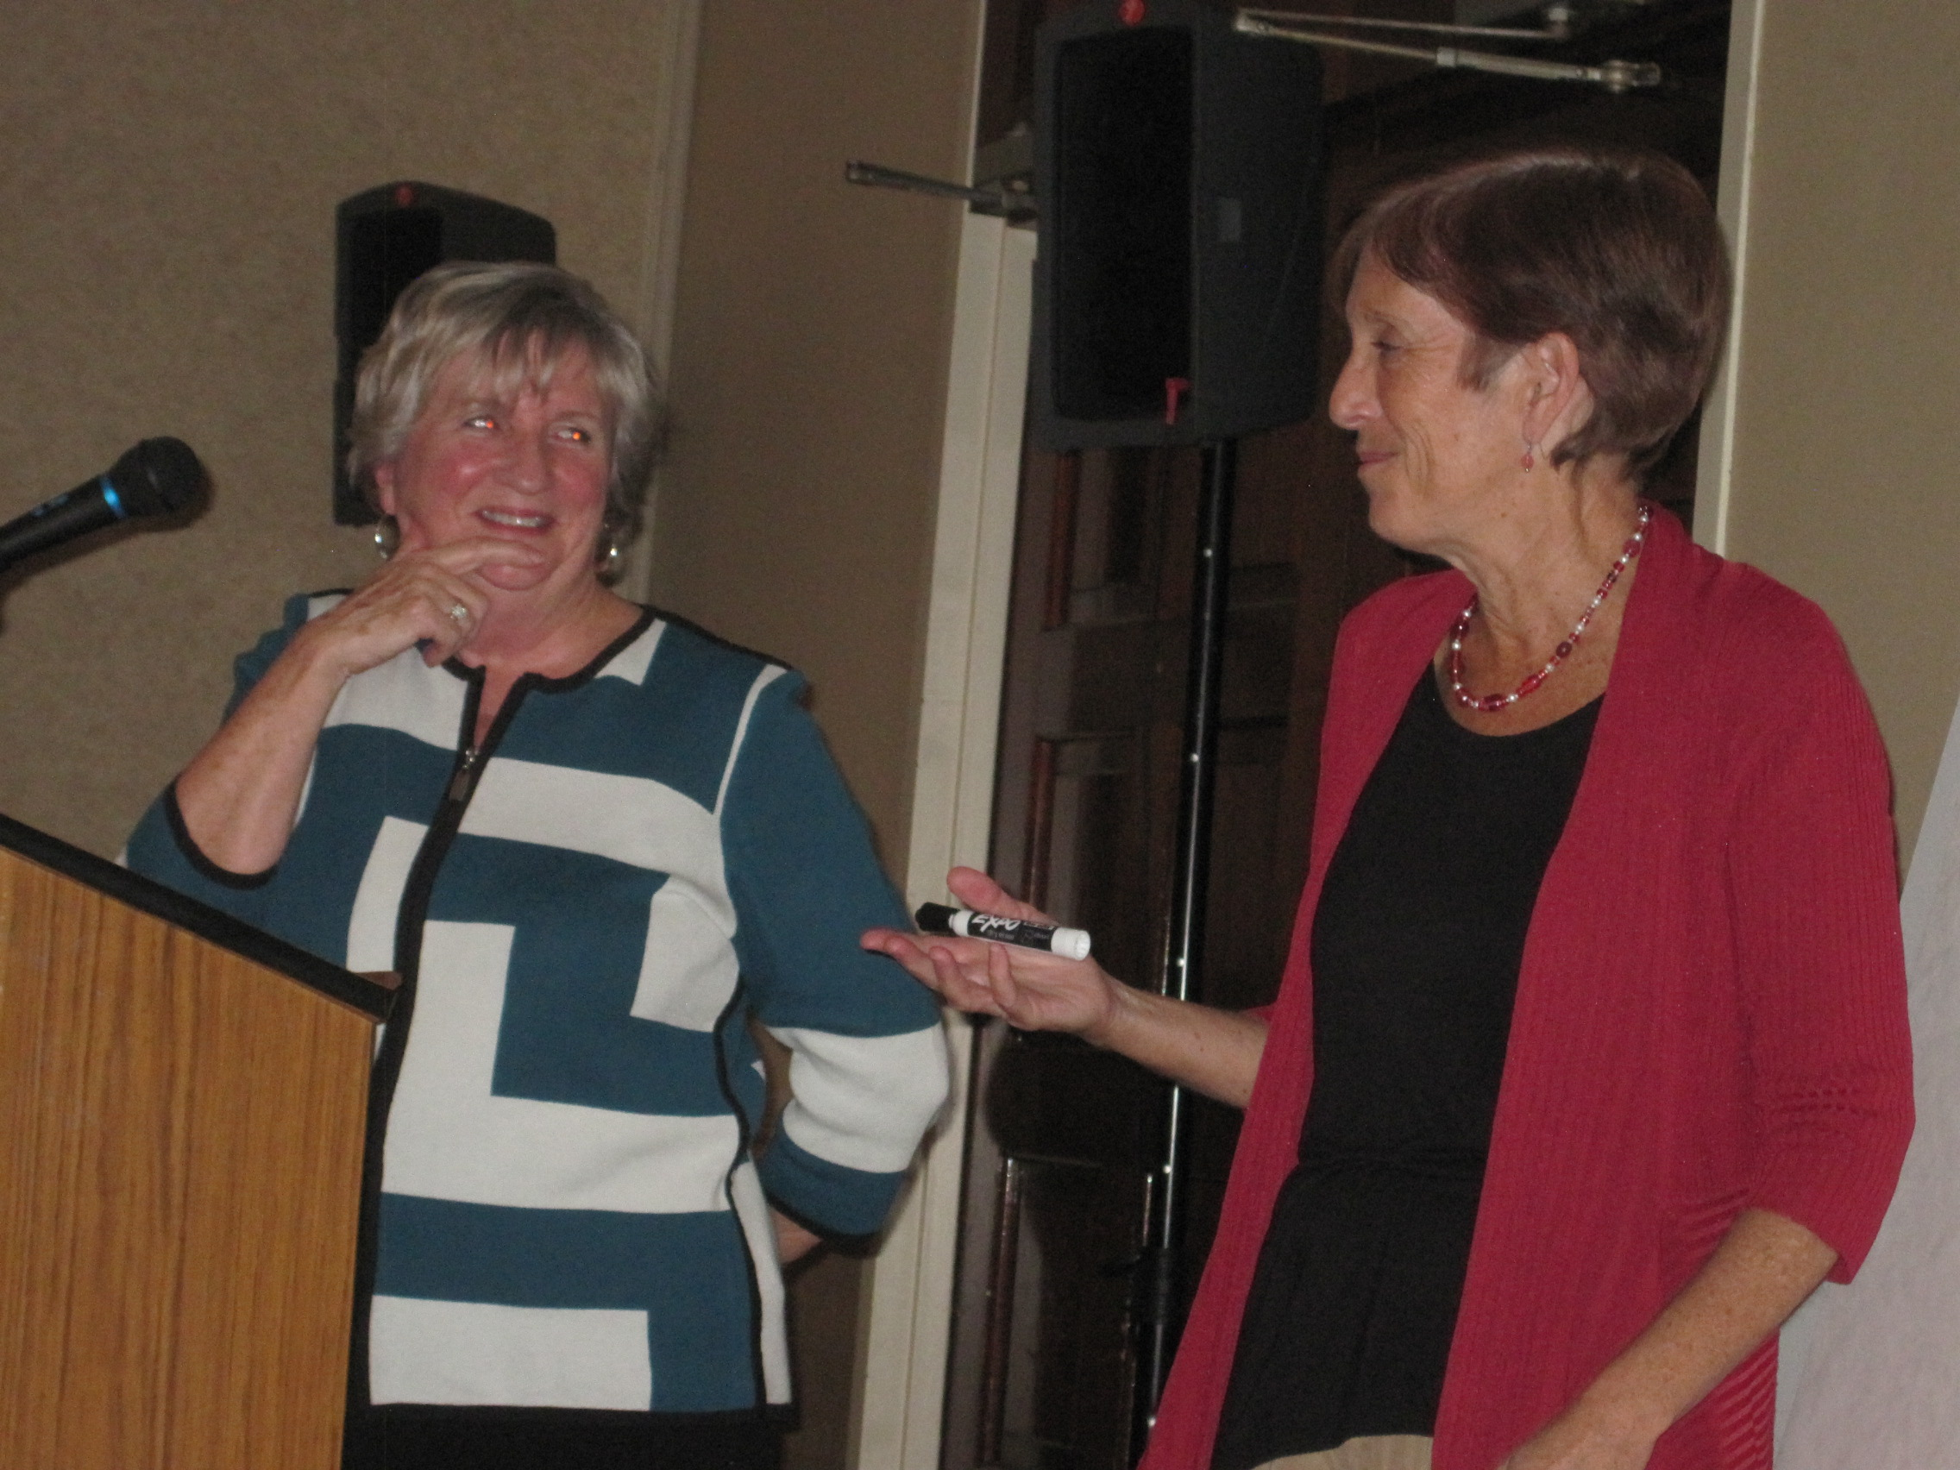

Alice Taylor and Eileen Conway-Martin

presenters at workshop on October 21, 2013

**A Learning Framework**

Given the centrality of the learner to the education process, Education 20/20 held a community workshop on the learning process in Charlottetown on Monday evening, October 21. The workshop was designed to give participants a chance to look at learning from a learner’s point of view. To start the discussion, learners were asked to recall their most memorable learning experience and how it impacted their lives.

The workshop was led by Alice Taylor, PEI partner of Handle with Care Program, Eileen Conway-Martin, Communications Director, Native Council of PEI, and Brenda Goodine, Learning Manager, Early Childhood Education, Holland College. Each learner is unique in that he or she brings their previous learning experience to each new one; they also bring unique plans, hopes and expectations for their future. Those who want to help learners need to understand the learning process and select the kind of support that will be of the greatest help.

**People for Education**

My recent Email from People for Education carried a number of interesting articles this month (<http://www.peopleforeducation.ca/>). I was especially interested in the results of a study from London’s Institute of Education that found “reading for pleasure was more important for students’ cognitive development than their parents’ education, and students whose parents read aloud to them at age 5 did better at age 16 in math, vocabulary, and spelling tests.”

**We appreciate your support**.

Education 20/20 thanks the following for their financial support:

* R. Birt and Associates
* Metro Credit Union
* Indigo Books & Music
* Anonymous donors

**The Walrus** of November 2013 carried an article by Sherman Zander,Standard Issues, about the alternative pedagogy of Joe Bower, an Alberta teacher, who, as a reward for his innovative methods, found himself transferred to a school where he could do less harm. “By the time teachers like Bower set foot in a classroom, most of his decisions have already been made for him, by people he has never met, in buildings he has never visited, using rationale he may not agree with or support. Teachers are obliged to follow an administrative mandate that can make them feel more like automatons than educators.”

*Guest Editor – Don Glendenning*

***Education 20/20 Inc.***

101 Kent St., PO Box 624/rue Kent, BP 624

Charlottetown, PEI C1A 1M0 Canada

Tel: 902-892-2060

Email: [pei@caneducation2020.com](mailto:pei@caneducation2020.com)

[www.caneducation2020.com](http://www.caneducation2020.com) –under construction